🌐 Network Fundamentals

📘 What This Section Is About
This section of the course introduces network fundamentals, which form the foundation for understanding how modern networks are designed, implemented, and maintained. When we talk about computer networks, we are not just referring to the internet or home Wi-Fi, but all systems that connect devices and allow data to flow between them.

🧠 What Is a Network?
A network is a collection of connected devices that exchange data. These connections can be:
- Wireless (Wi-Fi, cellular, Bluetooth)
- Wired (Ethernet, fiber optic)
Networks are not limited to computers. They connect phones, tablets, smartwatches, TVs, vehicles, servers, and more.

📱 Real-World Network Examples
- A smartwatch communicates with a smartphone using Bluetooth, forming a Personal Area Network (PAN) due to the short distance.
- A home Wi-Fi network connects phones, tablets, and laptops to the internet through a wireless access point, forming a Local Area Network (LAN).
- A desktop computer may connect to a switch, which connects to a router, then to a modem, and finally to the internet.
- All of these devices and connections together make up a complete network, even in a simple home environment.
This shows that even basic networks are diverse and complex.

🔀 Network Convergence
In the past, different services used separate networks:
- Telephone calls used one network
- Computer data used another
- Television/video used another
Today, networks are converged:
- Voice
- Data
- Video
All travel over one unified IP network.
Modern smartphones treat everything—calls, texts, browsing, video streaming—as digital data packets, regardless of the service being used.

⏱️ Availability and Uptime
Because we rely so heavily on networks, availability and uptime are critical.
- Customers often expect 100% uptime, but this is unrealistic.
- Instead, organizations define goals using Service Level Agreements (SLAs).
A common SLA target is 99.999% uptime, known as five-nines availability.
- This allows about 5 minutes of downtime per year
- It represents extremely high reliability, but not absolute perfection
The challenge for network technicians and administrators is to maintain this level of reliability continuously, year after year.

🌍 Modern Network Usage
Today’s corporate and home networks support many activities at once, including:
- File sharing
- Video calls (e.g., Zoom, FaceTime)
- Web browsing (e.g., Google, training platforms)
- Social media (LinkedIn, Facebook, TikTok)
- Streaming services (YouTube, Disney+, Netflix)
All of this traffic travels over the same internet connection because everything is broken into packets within an IP network.

⚠️ Growing Network Challenges
Network traffic is constantly expanding and evolving. Technicians must:
- Support new applications and services
- Handle increasing bandwidth demands
- Maintain five-nines availability despite growing complexity

🎯 Course Focus Areas
This section focuses on:
- Domain 1: Networking Concepts
- Domain 2: Network Implementation

Specific Exam Objectives Covered
- Objective 1.2: Compare and contrast networking appliances, applications, and functions
- Objective 1.6: Compare and contrast network topologies, architectures, and types
- Objective 2.3: Select and configure wireless devices and technologies based on a scenario

🧩 Topics Covered in This Section

🔧 Network Components
- Clients and servers
- Hubs and switches
- Wireless access points
- Routers and modems
- Firewalls
- Load balancers
- Proxies
- Intrusion Detection Systems (IDS)
- Intrusion Prevention Systems (IPS)

🗂️ Network Models
- Client-Server model
- Peer-to-Peer model

🗺️ Network Geography (by Size & Scope)
- Personal Area Network (PAN)
- Local Area Network (LAN)
- Campus Area Network (CAN)
- Metropolitan Area Network (MAN)
- Wide Area Network (WAN)
Includes discussion of:
- Network size
- Coverage area
- Appropriate use cases
- Real-world example using modern vehicles and onboard connectivity

🔗 Wired Network Topologies
- Point-to-Point
- Ring
- Bus
- Star
- Hub-and-Spoke
- Mesh

📡 Wireless Network Topologies
- Ad hoc
- Point-to-Point
- Infrastructure mode
- Wireless mesh

🏢 Data Center Topologies
- Three-tier model
- Collapsed core model
- Spine-and-leaf model
Also includes how traffic is classified:
- Entering the data center
- Leaving the data center
- Moving internally within the data center

📝 Assessment
The section concludes with:
- A quiz
- A review of correct and incorrect answers
- Explanations to reinforce learning

✅ Final Takeaway
This section prepares you to:
- Understand how networks function
- Recognize different network types and topologies
- Support modern converged networks
- Troubleshoot issues effectively
- Maintain high availability and uptime

🔹 What Is the OSI Model?
The OSI model stands for Open Systems Interconnection.
It was developed in 1977 by the International Organization for Standardization (ISO).
- ISO is responsible for creating international standards
- These standards are labeled with numbers (example: ISO 7498 = OSI Model)
- ❗ You do NOT need to memorize ISO numbers for the exam
- This is introduced so you understand that everything in computing is based on standards
The OSI model is often called:
- OSI Model
- OSI Stack
- OSI Reference Model
(All mean the same thing)

🔹 Why the OSI Model Is So Important (Especially for Network+)
The OSI model is foundational to networking and critical for the Network+ exam because:
- It is used to describe how networks work
- It helps categorize network functions
- It is heavily used in troubleshooting
- You WILL see exam questions related to:
  - OSI layers
  - Devices per layer
  - Data flow
  - Protocol behavior

🔹 OSI as a Reference Model
The OSI model is called a reference model because:
- It categorizes network functions into layers
- It provides a generic framework
- It allows engineers to:
  - Analyze
  - Compare
  - Troubleshoot networks consistently
👉 It does not always match exactly how modern networks work.

🔹 OSI vs Modern Networks (TCP/IP)
Modern networks actually operate using the TCP/IP model, not the OSI model.
Important points:
- Some technologies operate across multiple OSI layers
- Especially true in the upper three layers
- OSI is still used because it is:
  - Generic
  - Vendor-neutral
  - Technology-agnostic
👉 OSI works with any network type, not just TCP/IP.

🔹 Key Benefit of the OSI Model
The OSI model allows equivalent comparison across:
- Devices
- Vendors
- Technologies
Example:
- Compare Wireless Card A vs Wireless Card B
- Analyze how each functions at each OSI layer
- Helps you understand:
  - Data flow
  - Communication behavior
  - Troubleshooting steps

🔹 The Seven Layers of the OSI Model
The OSI model has 7 layers, numbered bottom to top:
Layer # | Layer Name
7 | Application
6 | Presentation
5 | Session
4 | Transport
3 | Network
2 | Data Link
1 | Physical
👉 You MUST memorize these in order (both directions) for the exam.

🧠 Mnemonic to Remember OSI Layers (Bottom → Top)

🥓 “Please Do Not Throw Sausage Pizza Away”
Mnemonic | OSI Layer
P | Physical
D | Data Link
N | Network
T | Transport
S | Session
P | Presentation
A | Application
Other valid mnemonics (used by students):
- Please Do Not Tell Shore Patrol Anything
- Please Do Not Teach Students Pointless Abbreviations
👉 Any mnemonic is fine — just memorize the order

🔹 OSI Exam Question Examples
You may be asked:
- What is Layer 7? → Application
- What layer is Session? → Layer 5
- What layer does a router operate at? → Layer 3 (Network)
- What layer does a hub operate at? → Layer 1 (Physical)
You will learn:
- Devices per layer
- Protocols per layer
- Troubleshooting techniques per layer

🔹 Data Names as It Moves Through OSI Layers
As data moves down the OSI model, its name changes.

📦 Data Naming by Layer
OSI Layer | Data Name
Layers 7–5 | Data
Layer 4 | Segment
Layer 3 | Packet
Layer 2 | Frame
Layer 1 | Bits

🧠 Mnemonic for Data Flow Names

❓ “Do Some People Fear Birthdays?”
Letter | Meaning
D | Data
S | Segment
P | Packet
F | Frame
B | Bits
👉 This follows data from top layers down to physical transmission

🔹 Encapsulation & Decapsulation (Very Important)

🔒 Encapsulation
- Data moves down the OSI model
- Each layer adds its own protocol information
- Data gets wrapped layer-by-layer

🔓 Decapsulation
- Happens on the receiving device
- Data moves up the OSI model
- Each layer removes its header

🔹 Wireshark (Coming Later in This Section)
You will use Wireshark, a network protocol analyzer, to:
- Capture live network traffic
- Analyze saved packet captures
- See how data is broken down by OSI layers
Used for:
- Inspection
- Troubleshooting
- Network analysis

🔹 How This Section Is Structured
- One lesson per OSI layer (7 total)
- Encapsulation & Decapsulation
- Wireshark packet analysis
- Short quiz
- Review of correct vs incorrect answers

✅ Final Exam Takeaways
You must know:
- All 7 OSI layers
- Proper layer order
- Data names per layer
- Encapsulation & decapsulation
- How OSI is used for troubleshooting
- Which devices operate at which layers

🔹 What Is the Physical Layer?
The Physical Layer (Layer 1) is the lowest layer of the OSI model.
Its job is only one thing:
Transmit raw bits (1s and 0s) across the network
It defines all physical and electrical characteristics of communication.

🔹 What Layer 1 Includes
Layer 1 answers questions like:
- Are we using Ethernet or Wi-Fi?
- Is the cable copper or fiber?
- Are we using Cat 5 or Cat 6?
- Are we using radio frequencies?
- How are bits physically represented?
No matter the medium:
- Data at Layer 1 is always BITS
- Bits are binary (1s and 0s)

🔹 How Bits Are Represented (Critical Concept)

🔌 Copper Cables (Cat 5 / Cat 6)
- Bits are represented by voltage levels
- Example:
  - 0 bit → 0 volts
  - 1 bit → +5V or −5V
- Switching between voltage levels tells the receiver whether it’s a 1 or 0
- This switching is called Transition Modulation
- ❗ You do NOT need deep math for the exam — just the concept
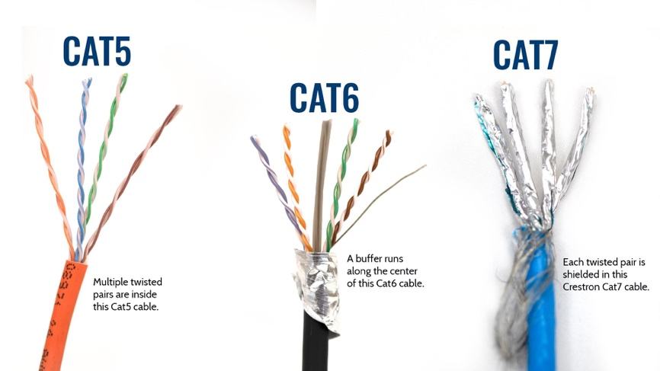

💡 Fiber Optic Cables
- Uses light instead of voltage
- Example:
  - Light ON → 1
  - Light OFF → 0
- Receiver reads the state of the light
- Transitions determine bit values
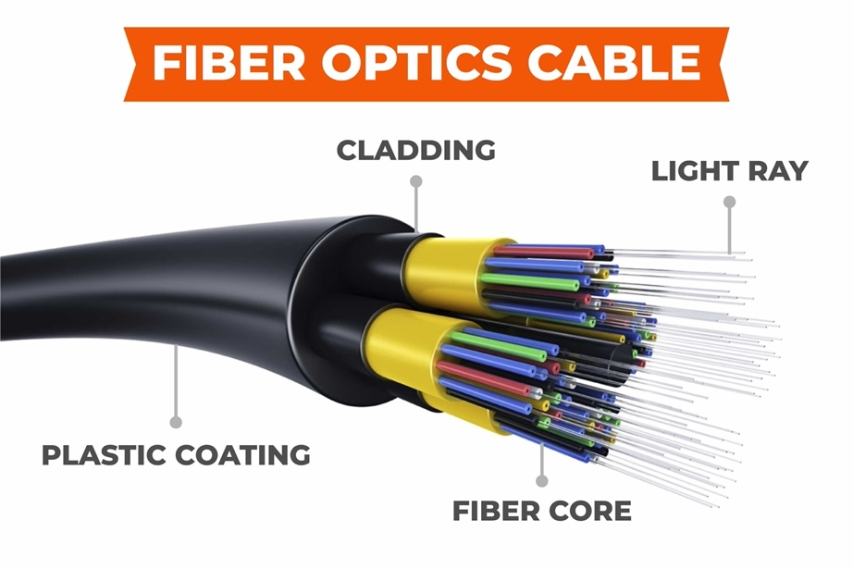

🔹 Cables & Connectors (Still Layer 1)
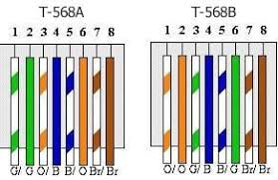
Physical cables and connectors are Layer 1 components.

🔌 RJ45 Connectors
- Used with Ethernet cables
- Wiring follows strict standards:
  - TIA/EIA-568A
  - TIA/EIA-568B

These standards define:
- Which wire color goes to which pin
- How devices send and receive bits

🔁 Straight-Through vs Crossover Cables
Cable Type | Wiring
Straight-through (patch cable) | B on both ends
Crossover cable | A on one end, B on the other  - Same devices transmit on the same pins  - Crossing swaps TX ↔ RX, so devices can hear each other
- Crossover cables swap transmit and receive pins
- Exam may require:
  - Drag-and-drop wire colors
  - Identifying correct wiring
👉 This is why wiring standards matter.
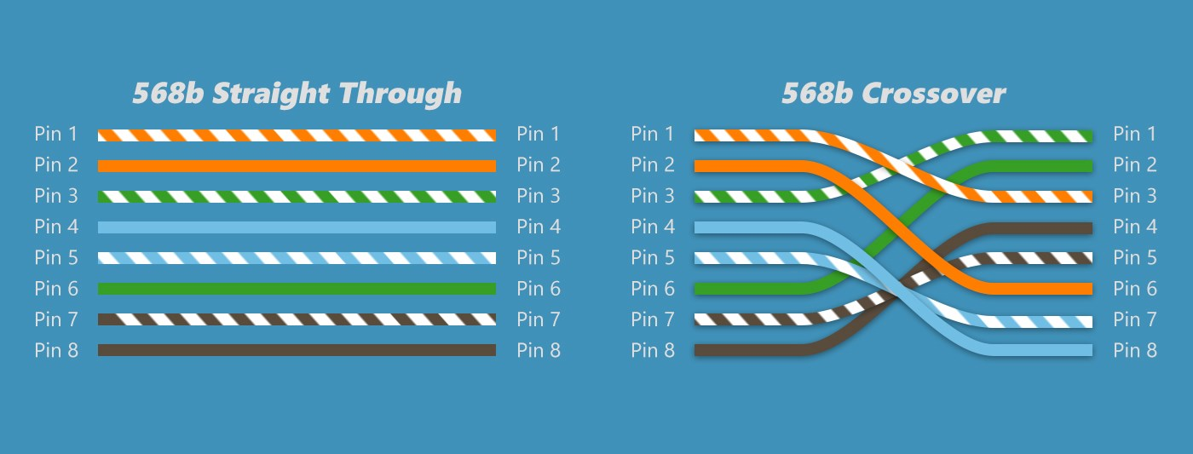

🔹 Physical Topology (Layer 1)
Topology = how devices are physically connected
Examples:
- Bus
- Ring
- Star
- Hub-and-spoke
- Full mesh
- Partial mesh
How to identify:
- Draw the cables
- Look at the physical shape
- That shape = physical topology
⚠️ This is Layer 1, not logical topology.

🔹 Synchronization at Layer 1
The sender and receiver must agree on when bits are sent and read.

1️⃣ Asynchronous Communication
- Uses start bits and stop bits
- Analogy: voicemail
- Sender sends data → receiver reads later
- No shared clock

2️⃣ Synchronous Communication
- Uses a shared timing source (clock)
- Analogy: phone call
- Communication happens in real time
- No start/stop bits
- Data sent on a regular cadence

🔹 Bandwidth Usage: Baseband vs Broadband

📺 Broadband
- Splits bandwidth into multiple channels
- Example: Cable TV
  - One cable
  - 200+ channels
- User selects one channel; others filtered out

☎️ Baseband
- Uses entire bandwidth all the time
- Example:
  - Telephone line
  - Wired Ethernet
- Only one transmission at a time
- Higher performance per session

🔹 Multiplexing (Efficiency Concept)
Multiplexing = using limited bandwidth more efficiently
You do NOT need formulas — just understand the idea.

🕒 Time-Division Multiplexing (TDM)
- Fixed time slots
- Everyone waits their turn

📊 Statistical TDM (StatTDM)
- Dynamic time slots
- Only active users get bandwidth
- Much more efficient

🎚️ Frequency-Division Multiplexing (FDM)
- Bandwidth split into frequency ranges
- Similar to broadband channels
👉 Exam takeaway:
Multiplexing allows multiple users to share a baseband connection.

🔹 Physical Layer Devices (Layer 1 Devices)
Layer 1 devices are dumb.
They:
- Do not inspect data
- Do not make decisions
- Simply repeat or convert signals

Examples:

🔌 Media (Cables)
- Ethernet
- Fiber optic
- Coaxial

📡 Wireless Media
- Wi-Fi
- Bluetooth
- NFC

🧱 Infrastructure Devices
- Hubs
- Access points
- Media converters

Key Rule:
Whatever goes in → comes out
Examples:
- Hub repeats signals to all ports
- Media converter changes fiber ↔ copper
- No logic
- No intelligence

🧠 Final Exam Summary (Layer 1)
You must remember:
- Layer 1 = Bits
- Physical & electrical characteristics
- Cables, connectors, voltages, light
- Physical topology
- Synchronization (async vs sync)
- Baseband vs broadband
- Multiplexing concept
- Layer 1 devices = repeaters only

🔑 Golden Rule:
Layer 1 devices are dumb — they only repeat bits

🔹 What Is the Data Link Layer?
Layer 2 (Data Link Layer) takes the bits from Layer 1 and:
- Packages them into frames
- Transmits those frames across the network
- Performs:
  - Error detection & correction
  - Flow control
  - MAC address identification
  - Logical (not physical) topology control
👉 Layer 1 = bits
👉 Layer 2 = frames

🔹 Frames (Layer 2 Data Unit)
At Layer 2:
- Raw bits are grouped into frames
- Frames include:
  - Source MAC address
  - Destination MAC address
  - Data
  - Error-checking information
- ┌─────────────────────────────────────────────┐
- │ Destination MAC │ Source MAC │ Data │ FCS │
- └─────────────────────────────────────────────┘
Frames are the containers that move data between devices on the same local network.

🔹 MAC Addresses (Media Access Control)
A MAC address:
- Is a physical identifier
- Allows devices to communicate on a logical topology
- Is critical for switches and other Layer 2 devices

Key Facts (Exam Gold):
- 48 bits total
- Written as 12 hexadecimal characters
- Example: D2:51:F1:AA:BB:CC
- Each hex character = 4 bits

🧩 MAC Address Structure
Portion | Bits | Purpose
First half (OUI) | 24 bits (6 hex chars) | Identifies manufacturer
Second half | 24 bits | Identifies specific device
This is called the Organizationally Unique Identifier (OUI).

🧠 Social Security Analogy (From Your Text)
- First part → Who issued it (manufacturer)
- Second part → Who it belongs to (device)
Examples of vendors:
- Apple
- Dell
- Ralink
- Intel

🔹 Logical Topology vs Physical Topology
- Layer 1 → Physical topology (cables, layout)
- Layer 2 → Logical topology (who talks, when, and how)
At Layer 2:
- We no longer care how devices are physically wired
- We care about:
  - Who is allowed to transmit
  - Preventing devices from talking over each other

🔹 Media Access Control (Who Gets to Talk)
Layer 2 ensures orderly communication.

Classroom Analogy:
- Students raise hands
- Teacher calls on one student
- No one shouts over each other

Network Equivalent:
- Electronic rules decide:
  - When a device can transmit
  - When it must wait
This prevents collisions and confusion.

🔹 Logical Link Control (LLC)
Logical Link Control provides:

1️⃣ Acknowledgment
- Receiver confirms frame arrival
- Similar to saying “Yes, I got your message”

2️⃣ Flow Control
- Prevents receiver from being overwhelmed
- Receiver can request:
  - Slower transmission
  - Retransmission
Classroom analogy:
“Slow down, I don’t understand.”

3️⃣ Error Control (Checksum)
- Receiver calculates a checksum
- Compares it to the received checksum
- If mismatch:
  - Frame is corrupted
  - Retransmission requested
👉 Uses even/odd parity logic

🔹 Layer 2 Communication Timing Methods
Layer 2 can coordinate communication in three ways:

1️⃣ Isochronous
- Uses a shared clock
- Uses fixed time slots
- Very low overhead
- Predictable timing
Think:
- Scheduled speaking slots
- Everyone knows exactly when and how long to talk

2️⃣ Synchronous
- Shared clock
- Uses:
  - Start frames
  - End frames
  - Control characters
- Efficient but rigid
- Little unused time
Music analogy:
- Time signatures (3/4, 4/4)
- Fixed beats per measure

3️⃣ Asynchronous
- No shared clock
- Devices use:
  - Start bits
  - Stop bits
- Flexible but inefficient
- Less control over timing

🔹 Layer 2 Devices
Layer 2 devices use logic, unlike Layer 1 devices.

Common Layer 2 Devices:
- Network Interface Cards (NICs)
- Bridges
- Switches

🧠 Switch vs Hub (Important Difference)
Hub (Layer 1) | Switch (Layer 2)
Dumb | Smart
Repeats everything | Sends only where needed
No MAC awareness | Learns MAC addresses
Broadcasts blindly | Uses logic

🔹 How Switches Work (Preview)
- Learn MAC addresses
- Map MACs to ports
- Store info in CAM tables
- Forward frames intelligently
👉 You’ll study this in detail later.

🧠 Final Exam Summary (Layer 2)
You MUST remember:
- Layer 2 = Frames
- Uses MAC addresses
- MAC = 48-bit hexadecimal
- Logical (not physical) topology
- Flow control & error detection
- Uses checksums
- Devices: NICs, bridges, switches
- Switches are intelligent
- Layer 2 prevents devices from talking over each other

🔑 Golden Rule
Layer 2 controls who talks, when they talk, and ensures frames arrive correctly.

🔹 What Is the Job of Layer 3?
The Network Layer (Layer 3) is responsible for routing.

In simple words:
Layer 3 decides how data gets from one network to another using logical addresses.

🧠 Key Responsibilities of Layer 3
Layer 3 focuses on:
- Routing (forwarding traffic)
- Logical addressing
- Path selection
- Packet delivery across networks

🔹 Logical Addressing (IP Addresses)
At Layer 3, devices use logical addresses, not physical ones.

Common Logical Addresses:
- IPv4
- IPv6
These are:
- Layer 3 protocols
- Used to identify networks and hosts
- Independent of hardware
📌 Example IPv4 address:
172.16.254.1
This format:
- Four numbers
- Separated by dots
- Called dotted decimal (dotted octet) notation

🔹 Layer 3 Is NOT Just IP
IP is the most common Layer 3 protocol, but not the only one.

Historical examples:
- AppleTalk (old Apple networks)
- IPX (Novell networks)
These are legacy protocols, no longer common, but they prove that:
Layer 3 is about routing, not just IP.

🔹 Routing vs Switching (Important Clarification)
This is a common confusion.
- Switch (device) → Layer 2
- Switching (function at Layer 3) → Routing
So:
Layer-3 “switching” = routing
Keep this straight:
- Physical switch device = Layer 2
- Routing / packet forwarding = Layer 3

🔹 How Data Is Forwarded at Layer 3
There are three forwarding methods:

1️⃣ Packet Switching (MOST COMMON)
Used by almost all modern networks
- Data is split into packets
- Each packet:
  - Has a destination IP
  - Can take different paths
- Routers forward packets hop-by-hop
📬 Mail analogy:
- Each letter may take a different route
- You don’t care how it gets there
- You only care that it arrives
📌 Internet = packet-switched network

2️⃣ Circuit Switching
- A dedicated path is created
- Same path used for the entire session
☎️ Phone call analogy:
- Connection stays the same during the call
- Released when call ends
📌 Rare in modern data networks

3️⃣ Message Switching
- Entire messages are:
  - Stored
  - Then forwarded
- Similar to email
- If a node is unavailable, data waits
📌 Rare today, mostly historical

🔹 Route Discovery & Route Selection

Big Question:
Which path should the packet take?
Routers solve this using routing tables.

How routers learn routes:
- Static routes (manually configured)
- Dynamic routing protocols, such as:
  - RIP
  - OSPF
  - EIGRP
Routers:
- Talk to each other
- Share network information
- Choose the best and fastest path
🧭 GPS analogy:
- Routes change based on traffic
- Best path chosen dynamically

🔹 Connection Services at Layer 3
Layer 3 adds reliability features beyond Layer 2.

1️⃣ Flow Control
- Prevents sender from overwhelming receiver
- Receiver can say:
  - “Slow down”
  - “Send more”

2️⃣ Packet Sequencing & Reordering
- Packets are numbered
- May arrive out of order
- Receiver:
  - Reorders packets
  - Reassembles data correctly
📦 Example:
Packets arrive as: 1, 5, 2, 4, 3
Reassembled as: 1, 2, 3, 4, 5

🔹 ICMP (Internet Control Message Protocol)
ICMP is a Layer 3 protocol used for:
- Status messages
- Error reporting
- Troubleshooting

Common ICMP tools:

🔍 Ping
- Sends a test packet
- Confirms:
  - Destination reachable
  - Response time

🧭 Traceroute
- Shows every router (hop)
- Identifies where failures occur
📌 Used by administrators, not applications

🔹 Layer 3 Devices (EXAM CRITICAL)

Devices:
- Router
- Multi-layer switch
⚠️ Exam rule:
- Switch = Layer 2
- Multi-layer switch = Layer 3

🔹 Layer 3 Protocols to Remember
- IP (IPv4, IPv6) ⭐ most important
- ICMP
- Routing protocols (for awareness)

🧠 Final Exam Summary (Layer 3)
You must remember:
- Layer 3 = Routing
- Uses logical (IP) addresses
- Data unit = Packet
- Packet switching is dominant
- Routers make forwarding decisions
- ICMP is used for troubleshooting
- Devices:
  - Router
  - Multi-layer switch

🔑 One-Line Exam Answer
Layer 3 is responsible for routing packets between networks using logical IP addresses.

🔹 What Is the Job of Layer 4?
Layer 4 (Transport Layer) is the boundary between the lower layers and the upper layers.

In simple terms:
Layer 4 is responsible for end-to-end communication, reliability, and controlling how fast data is sent.
- Below Layer 4 → network delivery (Layers 1–3)
- At and above Layer 4 → application communication (Layers 4–7)

📦 Data Unit at Layer 4
- Segment → used with TCP
- Datagram → used with UDP
👉 If you see segment or datagram, you are in Layer 4.

🔹 The Two Core Layer 4 Protocols

✅ TCP — Transmission Control Protocol
Reliable, connection-oriented

⚡ UDP — User Datagram Protocol
Fast, connectionless, unreliable

🟦 TCP Explained (Reliable Transport)

🔹 What TCP Does
TCP guarantees that:
- Data arrives
- Data arrives in order
- Missing data is resent

🔹 TCP Is Connection-Oriented
Before sending data, TCP establishes a connection using the three-way handshake:
- SYN → “Are you ready?”
- SYN-ACK → “Yes, I’m ready”
- ACK → “Great, here comes the data”
Only after this handshake does data transmission begin.

🔹 TCP Acknowledgements & Retransmission
- Every segment sent must be acknowledged
- If acknowledgements are missing:
  - TCP retransmits the missing segments
📌 Analogy: Certified mail
- You get proof the message arrived

🔹 TCP Is Used For
- Websites (HTTP/HTTPS)
- Banking
- Email
- File transfers
- E-commerce
👉 Anywhere accuracy matters

🟨 UDP Explained (Fast Transport)

🔹 What UDP Does
- Sends data without checking
- No handshake
- No acknowledgements
- No retransmissions
- No sequencing
👉 Data is sent and forgotten (fire-and-forget)

🔹 Why UDP Exists
UDP is ideal when:
- Speed matters more than perfection
- Small data loss is acceptable
📺 Examples:
- Video streaming
- Audio streaming
- Online gaming
- VoIP
If a tiny piece of data is lost:
- You usually don’t notice

🆚 TCP vs UDP (EXAM-CRITICAL)
Feature | TCP | UDP
Reliable | ✅ Yes | ❌ No
Connection-oriented | ✅ Yes | ❌ No
Three-way handshake | ✅ Yes | ❌ No
Retransmission | ✅ Yes | ❌ No
Sequencing | ✅ Yes | ❌ No
Overhead | High | Low
Speed | Slower | Faster

🔹 Windowing (TCP Performance Control)

🔹 What Is Windowing?
Windowing allows TCP to dynamically adjust how much data is sent before waiting for acknowledgements.
- Large window → faster sending
- Small window → safer sending

🔹 Why Windowing Matters
- Too much data → retransmissions
- Too little data → slow transfer
TCP continuously:
- Opens the window if things go well
- Closes the window if errors occur
📌 This is why file copy time estimates jump around.

🔹 Buffering (Temporary Storage)

🔹 What Is Buffering?
Buffering temporarily stores data when the network can’t transmit it immediately.
- Routers and devices have buffers (memory)
- Data waits until bandwidth becomes available

🔹 Why Buffers Can Overflow
If:
- Incoming traffic > outgoing capacity
- Buffer fills up
- Data gets dropped
📌 Example:
- 210 Mbps coming in
- 50 Mbps going out
- Excess data waits in buffer

🔹 Why This Is Done
- Saves money
- Most networks are not fully utilized all the time
- Allows smaller WAN links

🔹 Layer 4 Devices & Technologies

Layer 4 Protocols
- TCP
- UDP

Layer 4 Devices
- Firewalls (port-based filtering)
- Load balancers
- WAN accelerators
Layer 4 devices control, distribute, or optimize traffic using transport-layer information such as ports and protocols.
📌 Example:
- Blocking TCP port 80 → Layer 4 filtering

🧠 Final Exam Summary (Layer 4)
You must remember:
- Layer 4 = Transport
- Data units:
  - Segment (TCP)
  - Datagram (UDP)
- TCP:
  - Reliable
  - Handshake
  - Retransmission
  - Sequencing
- UDP:
  - Fast
  - No guarantees
- Performance tools:
  - Windowing
  - Buffering
- Common protocols:
  - TCP
  - UDP

🔑 One-Line Exam Answer
Layer 4 provides end-to-end transport, reliability, flow control, and segmentation using TCP or UDP.

What is the Session Layer?
Layer 5 (Session Layer) is responsible for managing conversations (sessions) between two systems on a network.
A session is a logical, ongoing exchange of data that must stay separate from other conversations so data doesn’t mix up.
Think of it exactly like your classroom example:
- Many students (many sessions) exist at the same time
- Each conversation is kept separate
- Conversations can start, continue, pause, and end independently

🎯 Core Responsibilities of the Session Layer

1️⃣ Session Establishment (Setup)
This is where a session begins.
What happens:
- User or system credentials are verified
- A session ID (unique number) is assigned
- Communication rules are agreed on (who talks first, what services are used)
💡 Analogy:
Johnny says, “Professor?”
You reply, “Yes, Johnny?”
➡️ Session established — both sides are ready to talk.

2️⃣ Session Maintenance
This is where the actual conversation happens.
What happens:
- Data flows back and forth continuously
- The session stays open
- Lost data or interruptions may require re-syncing
💡 Analogy:
Johnny asks questions → you answer → Johnny responds → back and forth
➡️ The session is being maintained
If something goes wrong:
- Data can be retransmitted
- Communication can be re-established

3️⃣ Session Termination (Teardown)
This is where the session ends.
Two ways it can happen:

✅ Graceful termination (mutual)
- Both sides agree communication is finished
- Resources are released cleanly
💡 Analogy:
“Does that answer your question?”
“Yes.”
➡️ Session closed normally

❌ Abrupt termination (disconnect)
- One side disappears or becomes unreachable
- Session is forcefully closed to free resources
💡 Analogy:
Johnny falls asleep
➡️ No response → session ends automatically

🔌 Why the Session Layer Matters
Without Layer 5:
- Data streams could mix together
- Multiple conversations would interfere
- Systems wouldn’t know who is talking to whom
It keeps conversations:
- Organized
- Synchronized
- Isolated

📡 Common Layer 5 Protocols (Very Exam-Relevant)

🎥 H.323
- Used for voice and video communication
- Handles session setup, maintenance, and teardown
- Common in video calls and conferencing systems
💡 Think: FaceTime, Skype, video calls

🔊 RTP (Real-Time Transport Protocol)
- Carries real-time audio and video
- Often works alongside H.323
- Designed for low latency, not guaranteed delivery
💡 Think: Live voice & video streams

🗂️ NetBIOS
- Used mainly in Windows networks
- Supports file sharing and name resolution
- Helps maintain communication sessions between systems
💡 Think: Windows file sharing

What NetBIOS is (simple explanation)
NetBIOS is a networking service that allows computers on the same local network to:
- Identify each other by name
- Establish sessions (conversations)
- Share files and printer

📝 Exam Memory Trick
If you see:
- Session
- Conversation
- Setup / Maintain / Teardown
- Video calls
- H.323 / RTP / NetBIOS
👉 The answer is Layer 5 – Session Layer

What is the Presentation Layer?
Layer 6 (Presentation Layer) is responsible for how data looks and how data is protected when it moves across a network.
If you remember only two keywords, remember these:
✅ Data formatting
🔐 Encryption
Anytime you hear formatting, encoding, compression, or encryption, think Layer 6.

🎯 Core Responsibilities of Layer 6

1️⃣ Data Formatting (Translation)
Different systems may “speak” data differently.
Layer 6 makes sure data is in a format both sides understand.
Even though everything is just 1s and 0s, the format tells the computer:
- “This is text”
- “This is an image”
- “This is a video”
- “This is audio”

Common formatting examples:
- Text formats
  - ASCII
  - Unicode
  - EBCDIC
- Image formats
  - GIF
  - JPEG / JPG
  - PNG
  - SVG
  - TIFF
- Video formats
  - MP4
  - MPEG
  - MOV
- Markup / scripting formats
  - HTML
  - XML
  - JavaScript
  - PHP
💡 Example:
The letter A is stored as a number (65 in ASCII).
Layer 6 ensures the receiving system displays it correctly as “A”, not random symbols.

2️⃣ Encryption (Security)
Layer 6 also protects data by scrambling it so attackers can’t read it.
This provides:
- 🔐 Confidentiality
- 🔐 Secure communication
- 🔐 Protection of passwords, credit cards, and personal data

Common encryption technologies:
- TLS (Transport Layer Security)
- SSL (Secure Sockets Layer)
💡 Example:
When you see the 🔒 lock icon in your browser:
- Your data is encrypted
- Hackers can’t read usernames, passwords, or credit card numbers

🧠 How Layer 6 Fits the OSI Model
Think of Layer 6 as a translator + security guard:
- 🗣️ Translator → makes sure data is readable
- 🛡️ Security guard → encrypts data so only the right person can read it
Layer 6 prepares data for Layer 7 (Application Layer), which actually uses the data.

📝 Exam Memory Tricks
If the question mentions:
- Encryption / TLS / SSL → Layer 6
- ASCII / Unicode → Layer 6
- JPEG, PNG, MP4 → Layer 6
- Formatting or encoding → Layer 6
📌 One-line exam answer:
The Presentation Layer formats data and encrypts it for secure transmission.

What is the Application Layer?
Layer 7 (Application Layer) is the closest layer to the user.
It provides network services that applications use to communicate over the network.
⚠️ Important clarification (exam trap):
This is NOT about apps like Chrome, Word, or Notepad themselves.
It’s about the network protocols and services those apps rely on.

🎯 What Layer 7 Actually Does
Layer 7 handles application-level services, meaning:
- It allows users and software to request network services
- It defines how network services are accessed
- It enables communication between applications across a network
Think of it as the interface between user software and the network.

🔧 Major Functions of Layer 7

1️⃣ Application Services
These are the actual network functions applications depend on.
Examples of services:
- Email transfer and retrieval
- Web browsing
- File transfer
- Remote access
- Network management
- Client–server communication
💡 When you send an email or open a website, Layer 7 decides how that request is handled on the network.
💡 When you open a website, Layer 7 decides whether the request uses HTTP or HTTPS and how the web service is accessed.
💡 When you send an email, Layer 7 determines whether SMTP is used to send it and whether POP3 or IMAP is used to retrieve it.
💡 When you upload a file to a server, Layer 7 selects the file transfer service such as FTP, FTPS, or SFTP.
💡 When you connect to another computer remotely, Layer 7 chooses whether the connection uses SSH or Telnet.
💡 When you type a website name, Layer 7 uses DNS to translate the domain name into an IP address.
💡 When your computer finds a printer on the network, Layer 7 handles the service advertisement that tells your system the printer is available.

2️⃣ Service Advertisement
This allows devices and services to announce what they offer on the network.
💡 Real-life example:
- You join a Wi-Fi network
- A printer announces:
“I’m a printer. You can print to me.”
- Your computer discovers it automatically
This is service advertisement, and it lives at Layer 7.

📡 Common Layer 7 Protocols (Very Exam-Important)

📧 Email
- SMTP – sends email
- POP3 – downloads email
- IMAP – syncs email across devices

🌐 Web
- HTTP – unencrypted web traffic
- HTTPS – encrypted web traffic

📁 File Transfer
- FTP – file transfer (unencrypted)
- FTPS – FTP with encryption
- SFTP – secure file transfer over SSH

🖧 Remote Access
- Telnet – remote command line (unencrypted)
- SSH – secure remote command line

📊 Network Services
- DNS – converts names ↔ IP addresses
- SNMP – network monitoring and management

🧠 How Layer 7 Fits with Other Layers
- Layer 7 → What service do I want?
- Layer 6 → Format & encrypt the data
- Layer 5 → Manage the session
- Layer 4 → Reliable or fast delivery
Layer 7 starts the request, and the lower layers handle delivery.

📝 Exam Memory Tricks
If the question mentions:
- Email protocols → Layer 7
- Web browsing → Layer 7
- DNS → Layer 7
- FTP / SSH / SNMP → Layer 7
- “User-facing network services” → Layer 7
📌 One-line exam answer:
The Application Layer provides network services directly to user applications.

